DEPLOY A MULTI-TIER WEB APPLICATION ON KUBERNETES

Step 1 : First check the minikube is there or not, if not there install

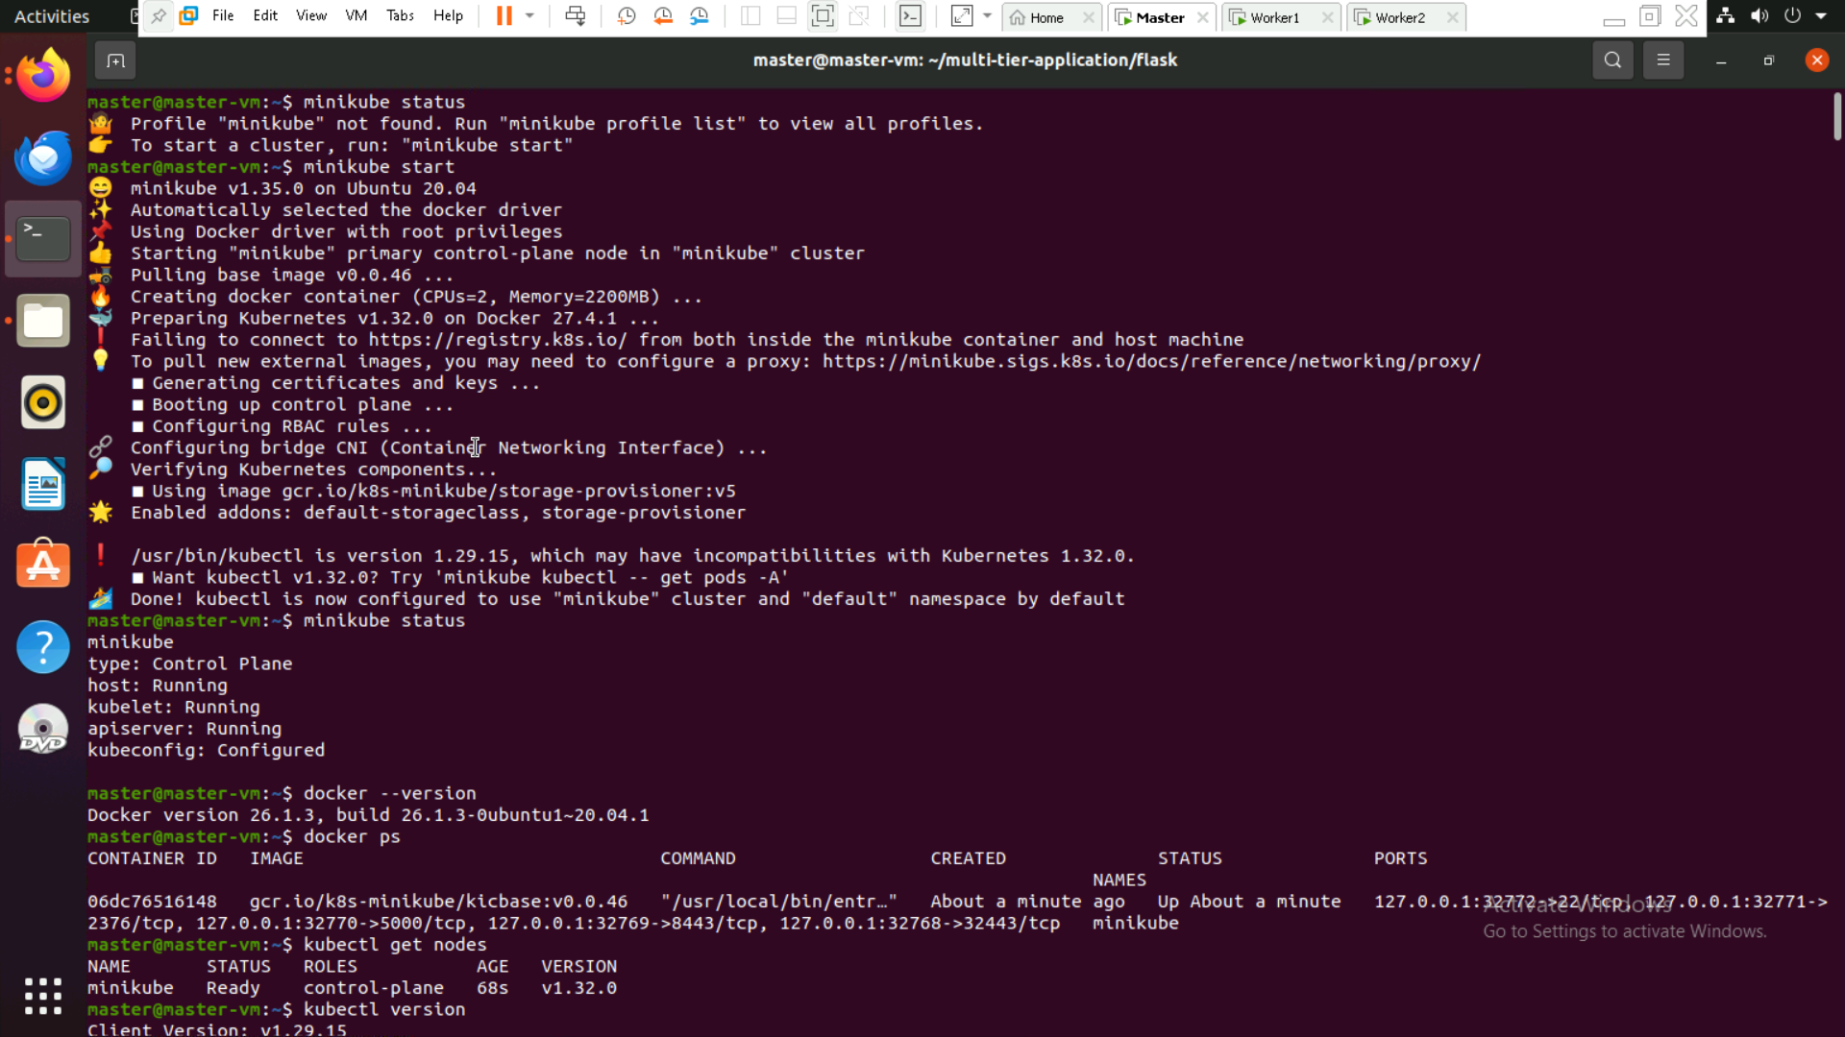

Step 2: Check docker install and node is connected or not

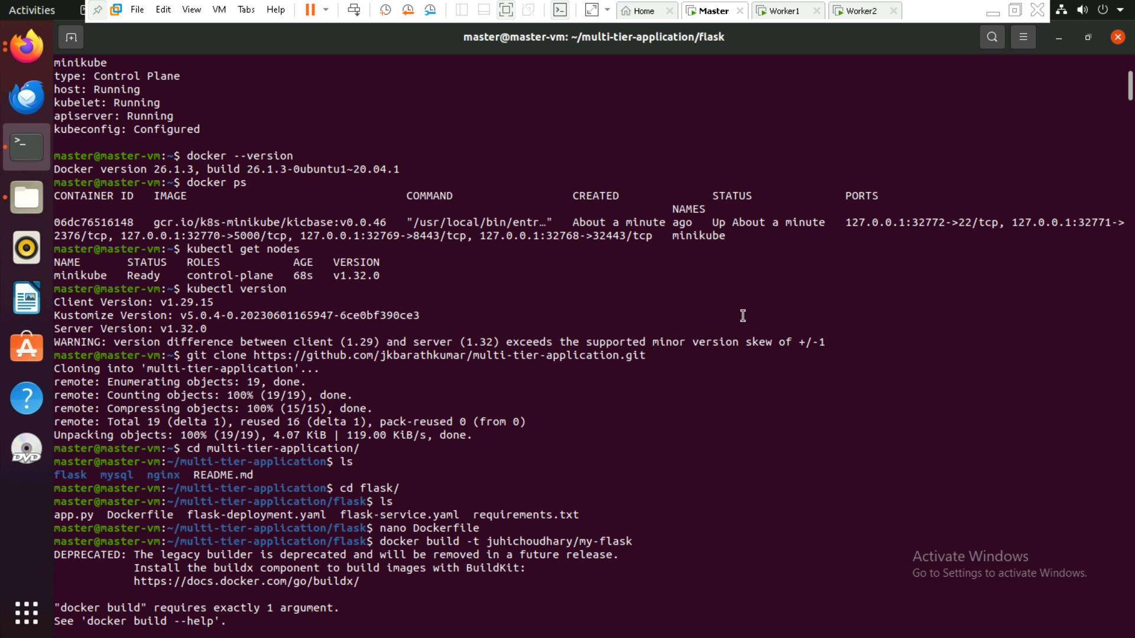

Step 3: Make directory and add all the files with code

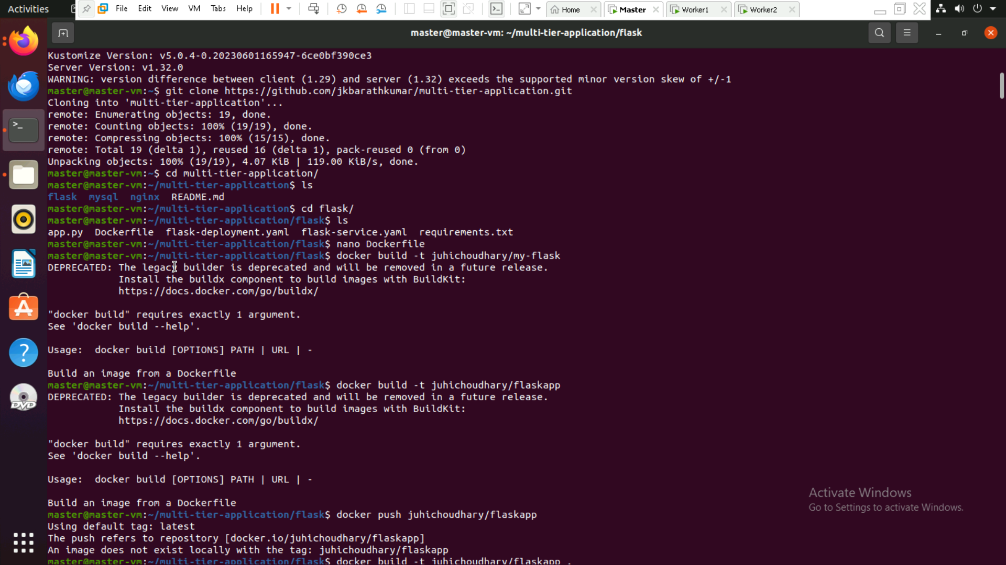

Step 4: Build the docker image and push to the docker hub

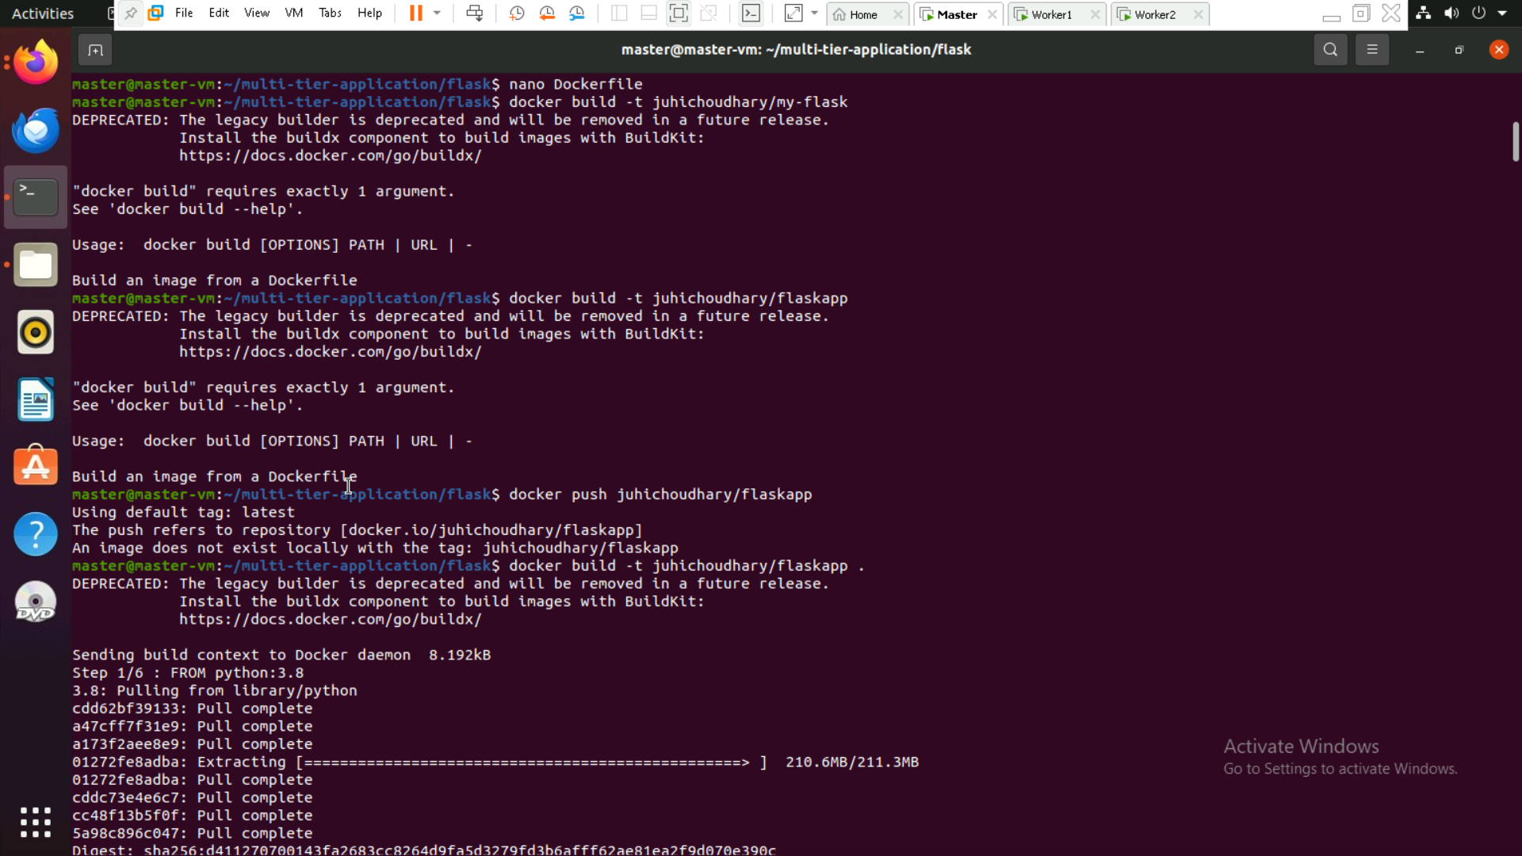

Step 5: login to the Docker and push the image

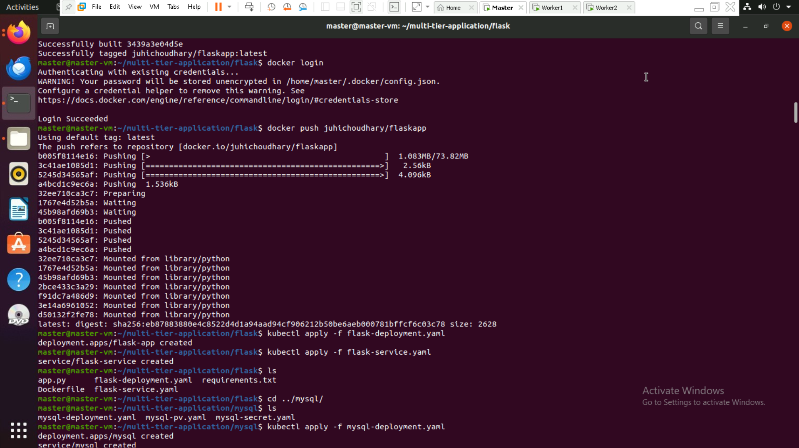

Step 6: Apply the configuration

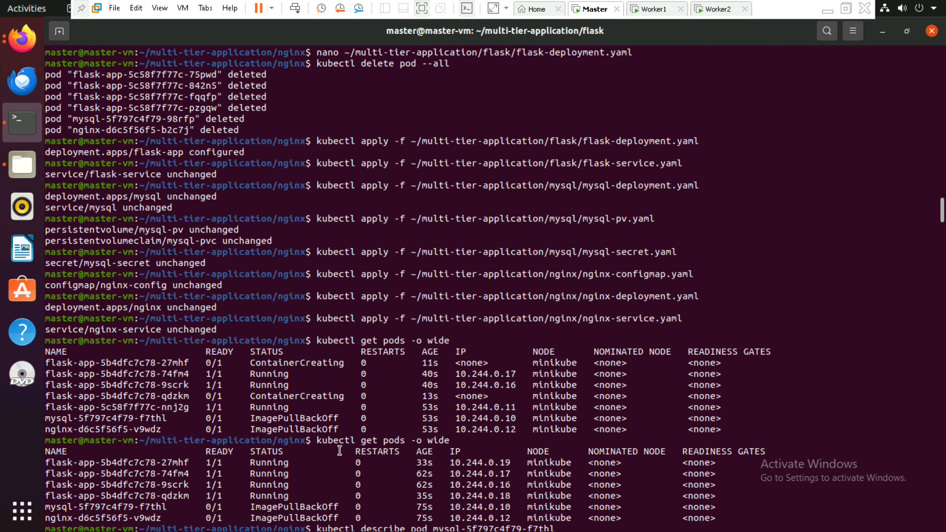

Step 7: get the all pods

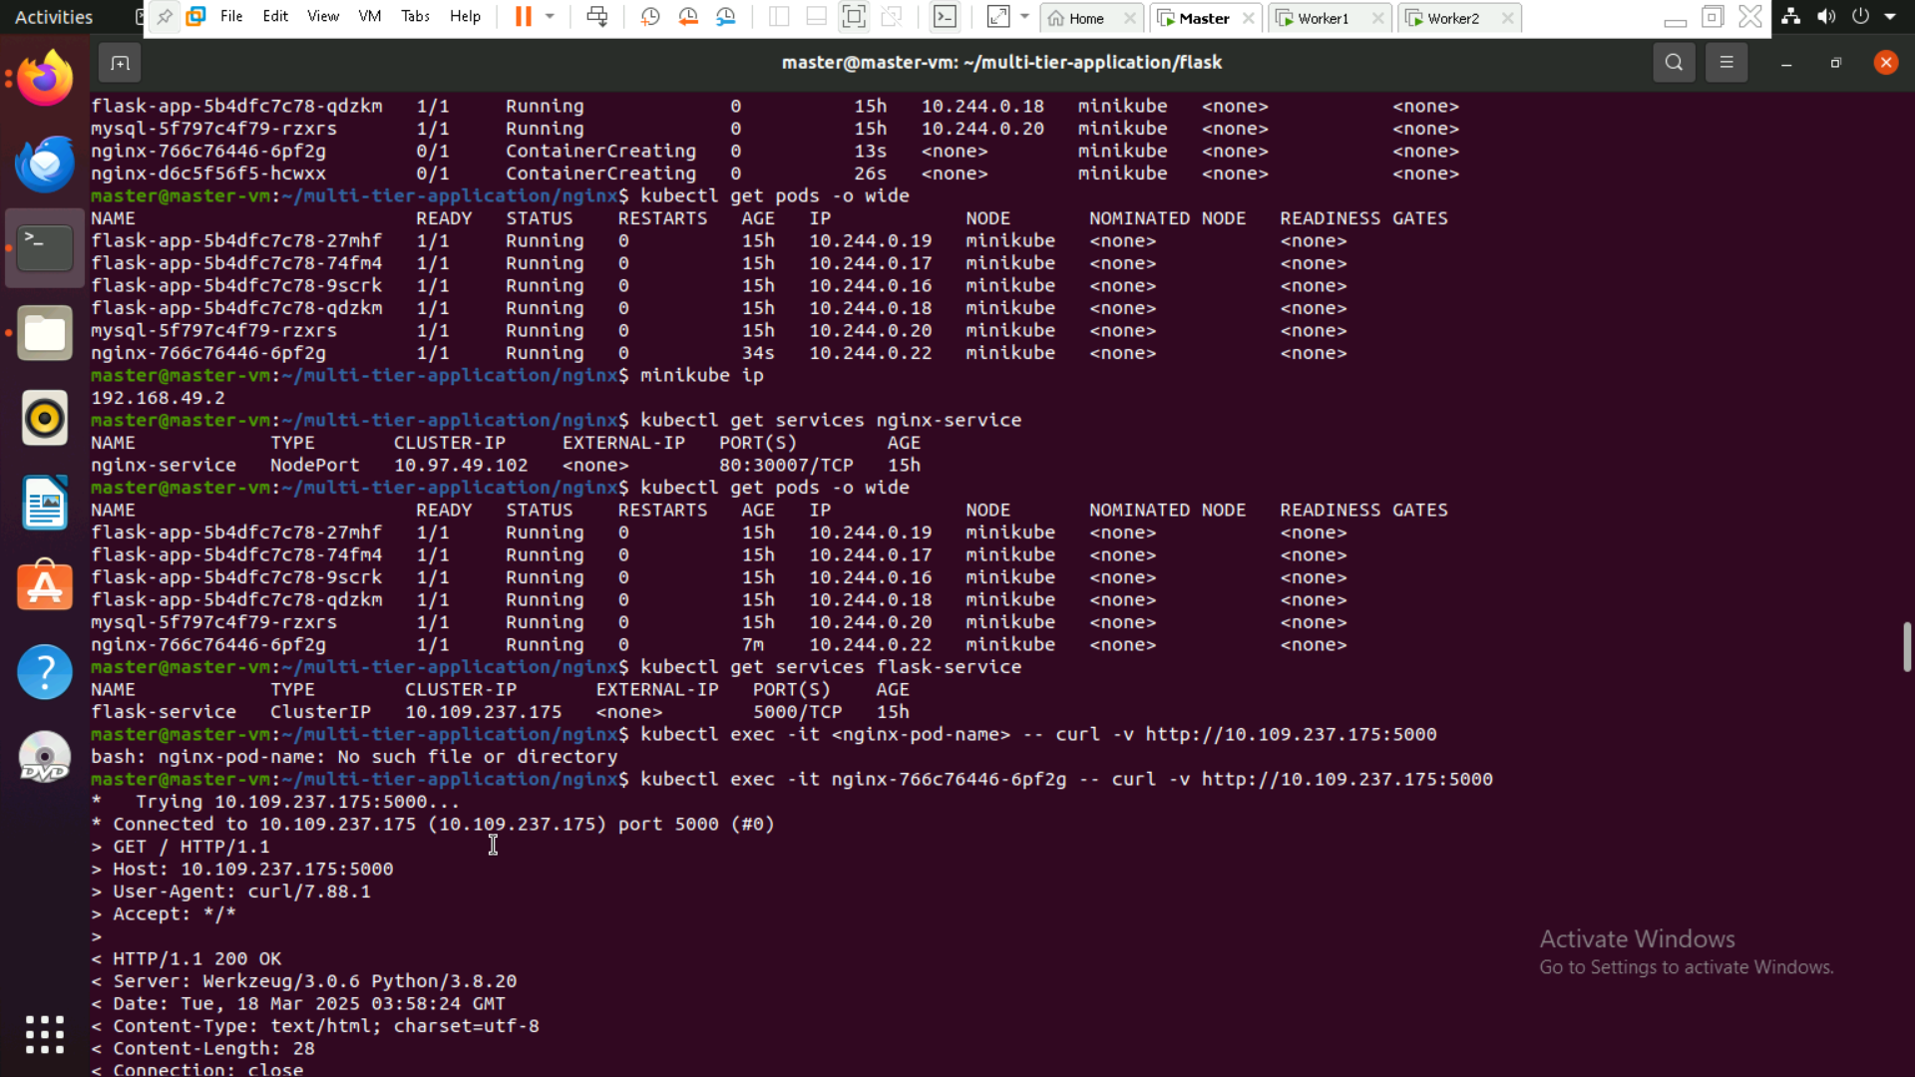

Step 8: database created and outputs

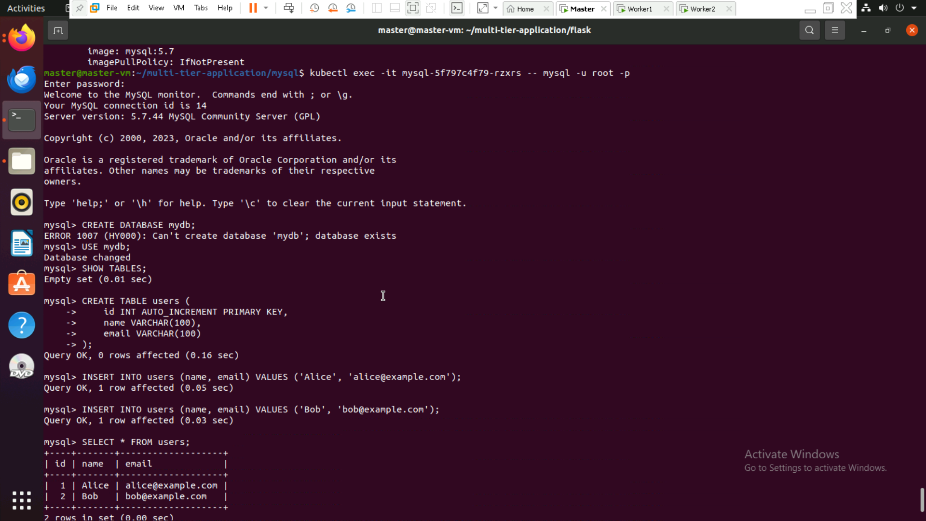

Step 9: open browser and run ip:30007

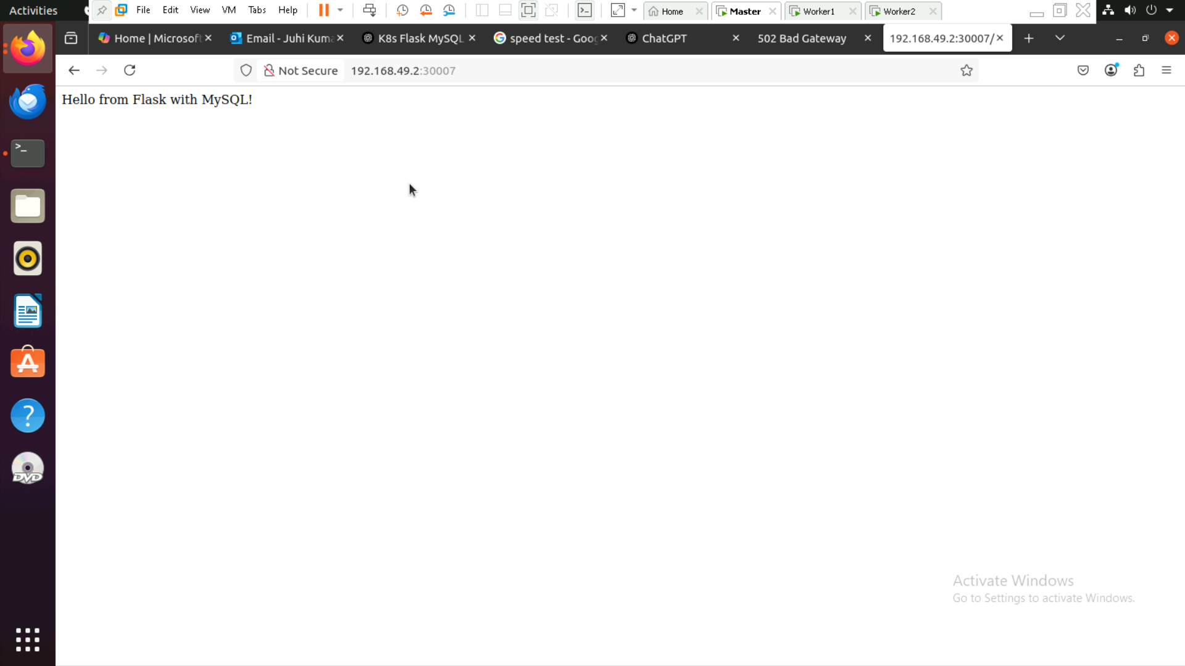

Step10: Database output table created

